# Installation Program - LaserBurn

1. Please download the aproproiate trial version of Laserburn from: <https://lightburnsoftware.com/pages/trial-version-try-before-you-buy>

PS. If you think the trial version is good, you could pay for it.

1. Install the software in your computer and run it.
2. Launch the application from your computer (Windows, MAC, Linux).
3. If it’s the first time you lauch LightBurn you will be prompted for the New Device Wizard.
4. Select GRBL and press Next Button.

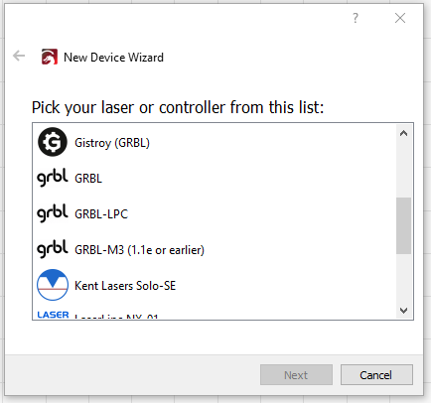

1. Select Serial/USB and press Next.

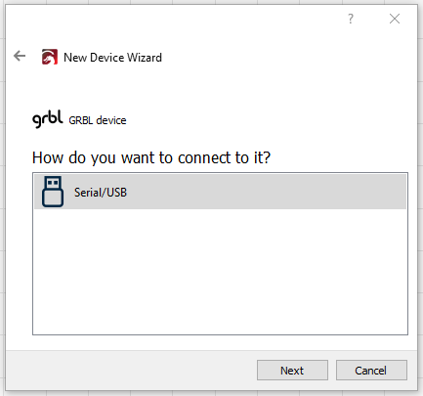

1. Fill your Device Name, as well as X and Y axis and press Enter
   1. Ortur Laser Master
   2. X = 400
   3. Y = 430

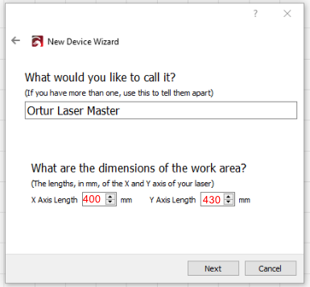

1. 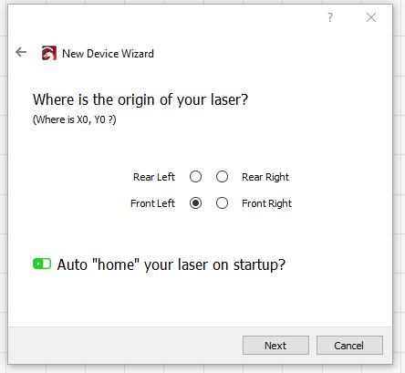Select Front Left as your Origin X,Y and activate Auto “Home”, then press Next.
2. Click Finish.
3. Select Ortur Laser Master and press Make Default.

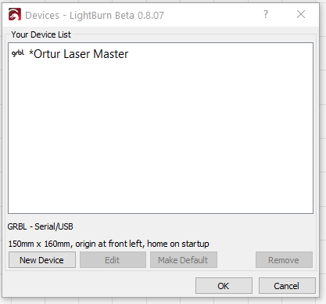

Your Ortur Laser Master 2 is ready to be used in LaserBurn software.